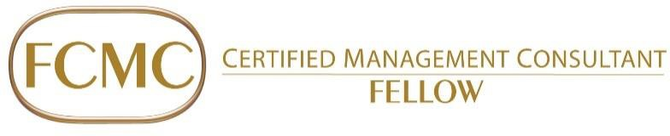

FCMC Designation Nomination Form

This form needs to be printed - Complete this form with as much detail as possible – Refer to ICMCA FCMC Nominations Guidelines Document. Save this file as the Nominee’s Name. When submitted, this form should be accompanied by a minimum of two letter/email recommendations from the nominators and other eligible CMC/FCMCs.

Nominee/Candidate Information:
Name: | CMC #:
Occupation/Description:
Address:
Phone:
Email:

Nominating CMC/FCMC Information:
The ICMCA members below hereby nominate the Candidate above for the designation of Fellow, Certified Management Consultant. As noted below, we attest to their outstanding contributions made to our profession, clients and community, plus their exemplary ethics and integrity of character and the validity of the information herein.

Signature Date Signature Date

Name CMC Member # Name CMC Member #

Email/Ph: Email/Ph:

Comments:

Using the space provided and where needed additional page(s), please provide the following:

A biographical sketch, including academic and professional degrees, work history, position, CV details:

Part 1 – Professional Excellence, Respect & Integrity
Provide details and examples of the Candidate’s demonstrated professional excellence and progress in their work over the span of their career. Discuss the Candidate’s ethical and professional practice. Comment with respect to how they have earned the respect of their peers. Use examples to support the foregoing. In preparing your comments please consider the following:

- Contribution: Progressively responsible work history demonstrated through advancement to a position of leadership and/or stature in an aspect of your management consulting;
- Integrity: Honesty, sincerity, confidentiality, avoidance of or dealing effectively with conflict of interest, and principled behavior;
- Transparency: Projecting truthful current status that reflects an honest and accurate reflection of yourself;
- Within the Profession: Visible promotion of integrity.

Part 2 – Pioneering and Innovation
Discuss how the Candidate has pioneered or further developed in an innovative manner, the profession, the consulting body of knowledge, practice development and management, and society in general. In providing your comments, please consider the following:

- Pioneering or innovative development: Illustrate how the Candidate has developed or contributed to the development of new methods or approaches; or applied existing methods or approaches in an innovative manner that advances the profession/consulting body of knowledge/consulting services/society.

Part 3 – Accomplishment and Contribution to the Profession, Society & Community
Discuss how the Candidate has contributed demonstrably to the profession, led significant and challenging projects and advanced benefits to society. In providing your comments, please consider the following:

- Accomplishment: Advance the profession, client, society;
- Contribution: Devoted considerable time and effort, or in other ways contributed demonstrably to the:
  - Profession (i.e. position/role within ICMCA, committees, marking exams, sponsoring new members, serving on a task force);
  - Client (non-billable services that advance the client, its industry or client staff);
  - Society, through volunteering/philanthropy demonstrate the Candidate’s management consulting competencies such as teaching, publishing and/or public speaking with no or token remuneration.
- Within Society: Include activities/involvement in the public sector, philanthropic activities, community and industry organizations

